# **Technical Analysis for the Problem**

First, the solution for this problem involves the design of a set of classes:

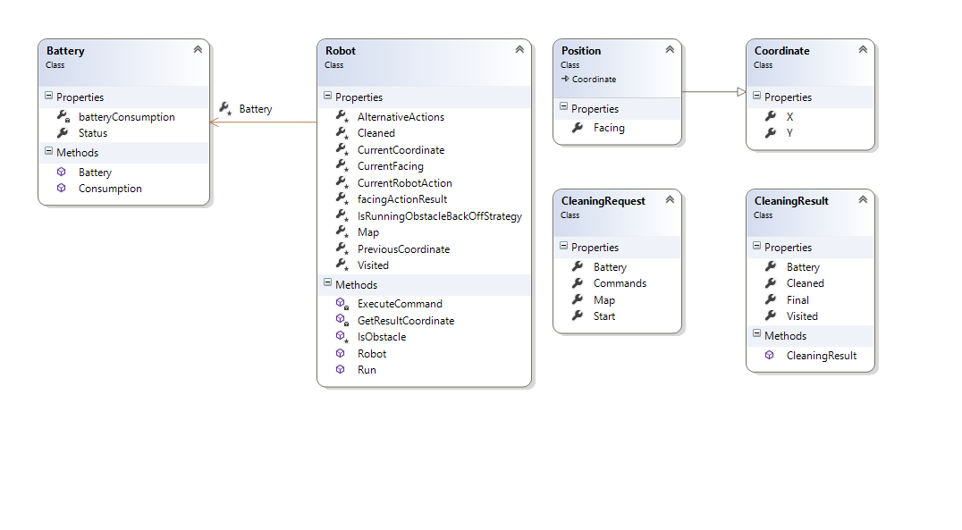

I separate the Robot Class and Battery Class to separate concerns and maintain its respective logic according to their objectives.

The classes CleaningRequest and CleaningResult are used by the Method **Run ()** located in **Robot** Class.

The class **Position** is a subclass from **Coordinate** Class. The Coordinate class stores the X and Y position where the Robot will clean. The **Position** Class additionally stores the **Facing** or orientation of the Robot i.e. North (N), South (S), East (E) or West (W).

# **Robot Class**

It contains the method to execute the instructions supplied in **CleaningRequest** class which is supplied in the console program.

The following section describes all the properties used in this class:

/// <summary>

/// Contains the Map used by the Robot to Clean

/// </summary>

protected string[][] Map { get; set; }

/// <summary>

/// Contains the coordinates X, Y where the Robot walks

/// </summary>

protected List<Coordinate> Visited { get; set; } = new List<Coordinate>();

/// <summary>

/// Contains the coordinates X, Y where the cleans

/// </summary>

protected List<Coordinate> Cleaned { get; set; } = new List<Coordinate>();

/// <summary>

/// Contains a matrix to store the result facing when an command (Turn Left or Turn Right) is applied knowing its initial facing

/// </summary>

protected string[][] FacingActionResult { get; set; } = new string[][] { new string[2] { "W", "E" }, new string[2] { "E", "W" }, new string[2] { "N", "S" }, new string[2] { "S", "N" } };

/// <summary>

/// Battery object that stores Status and Gets the Comsumption of Battery for each action

/// </summary>

protected Battery Battery { get; set; }

/// <summary>

/// Current Coordinate resulting of executing the Current Command

/// </summary>

protected Coordinate CurrentCoordinate { get; set; }

/// <summary>

/// Previous Coordinate used as backup when the current coordinate has an invalid value or state

/// </summary>

protected Coordinate PreviousCoordinate { get; set; }

/// <summary>

/// Current Facing where the Robot is looking

/// </summary>

protected Facing CurrentFacing { get; set; }

/// <summary>

/// Current command that is being executed

/// </summary>

protected RobotAction CurrentRobotAction { get; set; }

/// <summary>

/// Boolean that indicates if the Robot is running a Obstacle Backoff Strategy

/// </summary>

protected bool IsRunningObstacleBackOffStrategy { get; set; }

/// <summary>

/// Matrix to map the strategies commands if there are an obstacle

/// </summary>

protected string[][] AlternativeActions { get; set; } = new string[][] { new string[] { "TR", "A" }, new string[] { "TL", "B", "TR", "A" }, new string[] { "TL", "TL", "A" }, new string[] { "TR", "B", "TR", "A" }, new string[] { "TL", "TL", "A" } };

The protected string[][] **FacingActionResult** is the representation of the following table:

|  |  |  |
| --- | --- | --- |
| **Initial Facing** | **Applied Action** | **Resulting Facing** |
| N | TL | W |
| N | TR | E |
| S | TL | E |
| S | TR | W |
| E | TL | N |
| E | TR | S |
| W | TL | S |
| W | TR | N |
|  |  |  |

And the **AlternativeActions** are a collection of enumerated actions to be executed in case there is any obstacle.

The Boolean method **IsObstacle** indicates if there is an obstacle when it is being executed the current command. An obstacle depends of Current Coordinate, Map Position (X and Y) and Battery Status:

protected bool **IsObstacle()** => (CurrentCoordinate.X < 0 || CurrentCoordinate.Y < 0 || CurrentCoordinate.X >= Map.GetLength(0) ||CurrentCoordinate.Y >= Map.GetLength(0) || Map[CurrentCoordinate.Y][CurrentCoordinate.X] == "C" || Map[CurrentCoordinate.Y][CurrentCoordinate.X] == "null" || Battery.Status - Battery.Consumption(CurrentRobotAction) < 0);

**Method: public CleaningResult Run(CleaningRequest request)**

This method contains the logic to resolve every position where the Robot will be located and the process to execute the commands indicated in the Request Object.

Every command in **CleaningRequest.Commands** changes the Battery and Position represented by the object property **Battery** and the **CurrentCoordinate** Property.

The Algorithm for this Method is a very simple implementation which by means of iterating over **CleaningRequest.Commands** and using the method **ExecuteCommand** where the State is Changed (Battery and Position). In this iteration, it is evaluated if there is an Obstacle using the Boolean function **IsObstacle().**

If there is an obstacle, the **AlternativeActions** is iterated and resolved according the collections of commands supplied using the same Method **ExecuteCommand**.

At the end, all the state of the Robot class is returned.

var result = new CleaningResult();

Map = request.Map;

Battery = new Battery { Status = request.Battery };

CurrentCoordinate = request.Start;

PreviousCoordinate = CurrentCoordinate;

CurrentFacing = (Facing)Enum.Parse(typeof(Facing), request.Start.Facing);

Visited.Add(new Coordinate { X = CurrentCoordinate.X, Y = CurrentCoordinate.Y });

foreach (var command in request.Commands)

{

CurrentRobotAction = (RobotAction)Enum.Parse(typeof(RobotAction), command);

ExecuteCommand();

if (IsObstacle())

{

CurrentCoordinate = PreviousCoordinate;

IsRunningObstacleBackOffStrategy = true;

var alternativeIndex = 0;

do

{

var altCommands = AlternativeActions[alternativeIndex];

foreach (var altCommand in altCommands)

{

CurrentRobotAction = (RobotAction)Enum.Parse(typeof(RobotAction), altCommand);

ExecuteCommand();

}

if (!IsObstacle())

{

break;

}

else

{

CurrentCoordinate = PreviousCoordinate;

IsRunningObstacleBackOffStrategy = true;

}

alternativeIndex++;

}

while (IsRunningObstacleBackOffStrategy || alternativeIndex <= AlternativeActions.GetLength(0));

IsRunningObstacleBackOffStrategy = false;

}

}

result.Visited = Visited.OrderBy(m => m.X).ThenBy(m => m.Y).ToList();

result.Cleaned = Cleaned.OrderBy(m => m.X).ThenBy(m => m.Y).ToList();

result.Final = new Position { X = CurrentCoordinate.X, Y = CurrentCoordinate.Y, Facing = CurrentFacing.ToString() };

result.Battery = Battery.Status;

return result;

The above code shows part of the implemented code for the Method **Run**. The yellow part shows the normal execution and the green part shows the alternative execution when the Robot finds an Obstacle.

The Method **ExecuteCommand** process and changes the State of the Robot:

private void **ExecuteCommand**()

{

if (Battery.Status - Battery.Consumption(CurrentRobotAction) < 0)

{

return;

}

Battery.Status = Battery.Status - Battery.Consumption(CurrentRobotAction);

if (CurrentRobotAction == RobotAction.A || CurrentRobotAction == RobotAction.B)

{

PreviousCoordinate = CurrentCoordinate;

CurrentCoordinate = **GetResultCoordinate**(CurrentFacing,

CurrentRobotAction, CurrentCoordinate);

}

else if (CurrentRobotAction == RobotAction.TL ||

CurrentRobotAction == RobotAction.TR)

{

CurrentFacing =

(Facing)Enum.Parse(typeof(Facing),

FacingActionResult[(int)CurrentFacing][(int)CurrentRobotAction]);

}

if (!IsObstacle())

{

if ((CurrentRobotAction == RobotAction.A ||

CurrentRobotAction == RobotAction.B) &&

(!Visited.Any(m => m.X == CurrentCoordinate.X && m.Y == CurrentCoordinate.Y)))

{

Visited.Add(CurrentCoordinate);

}

else if ((CurrentRobotAction == RobotAction.C) &&

(!Cleaned.Any(m => m.X == CurrentCoordinate.X && m.Y == CurrentCoordinate.Y)))

{

Cleaned.Add(CurrentCoordinate);

}

}

}

The method **ExecuteCommand** uses the method **GetResultCoordinate** to resolve the next position when there is executed a command action (Advance or Back) according the **CurrentFacing** (North, South, East or West) and passing the **Current Coordinate**.